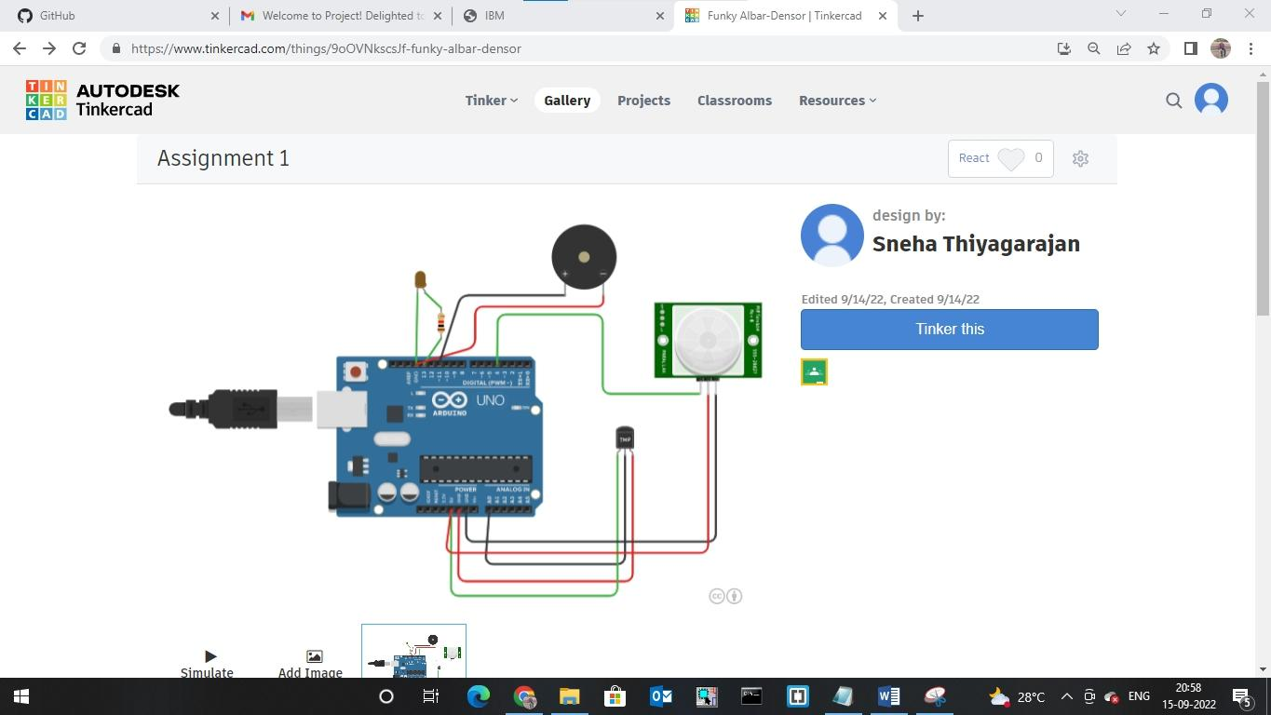https://www.tinkercad.com/things/9oOVNkscsJf?sharecode=w0DHhmptBtZbBrETYPShrYW2F_DIQGti7XAmhI4fw0c